Policies_Verifying Agency Billed Policy_Instance43_29-May-2018_03-18-01_AM_ValidationofAgencyBilledPolicy.png

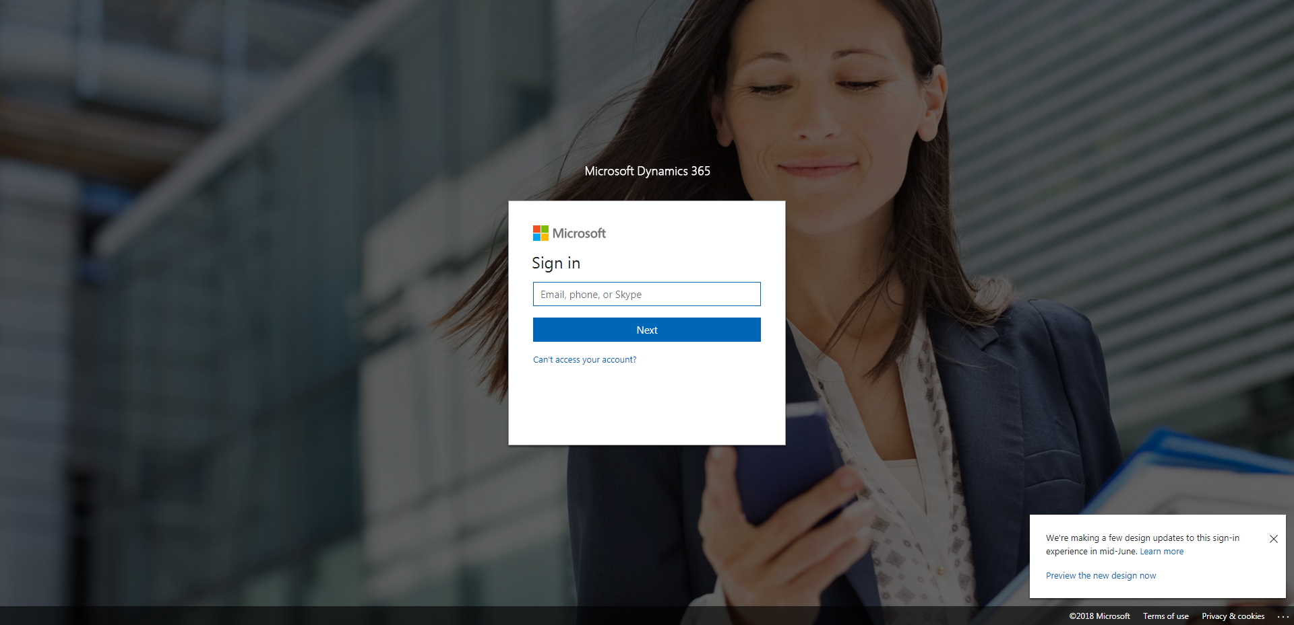

Policies_Verifying Agency Billed Policy_Instance43_29-May-2018_03-17-59_AM_SingleSignOn.png

